*TEST CASES*

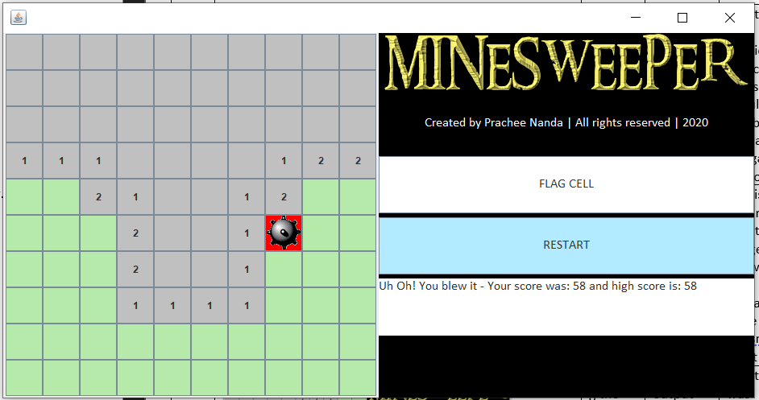**CASE #1:**

Input: Pressing green buttons after mine has been pressed

Output: No output

Remarks: This test was considered because users should not be able to play after the game was over.

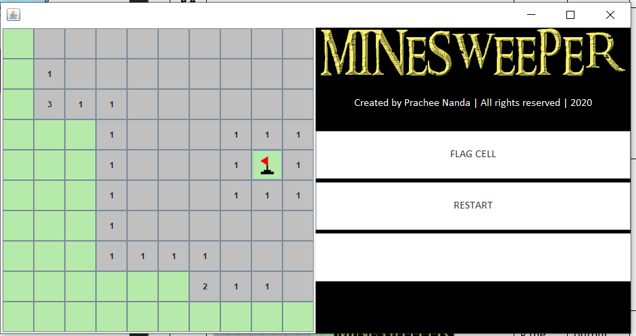Case #2:

Input: Pressing a tile that has been flagged and has a mine

Output: No Output

Remarks: This is to ensure that the flagged tile which may contain a mine doesn’t react

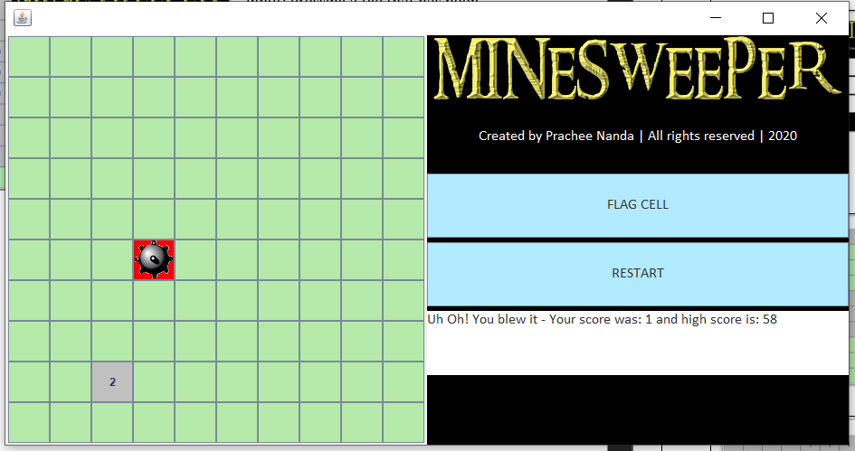

Case #3:

Input: After game over, trying to flag a cell

Output: No output

Remarks: This test was considered because users should not be able to play after the game was over.

Case #4

Input: The button on the 3rd Row, 2nd Column

Output: Recursion function output

Remarks: This test was done to test the recursion function on an edge.

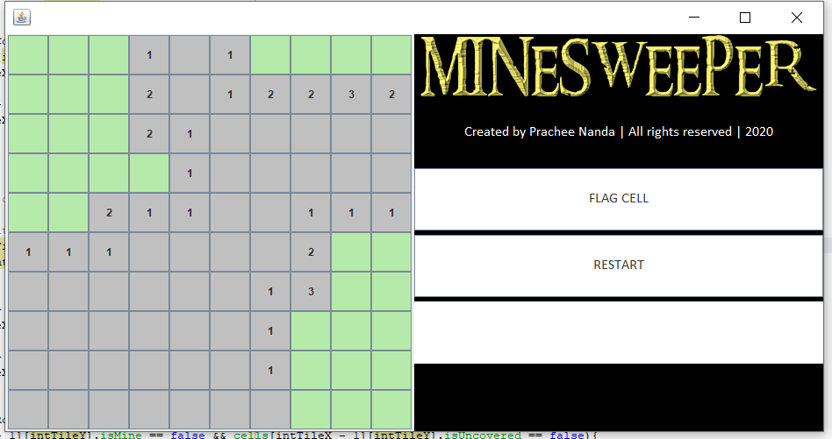

Case #5:

Input: The button in the first column, 7th row

Output: Recursion function output

Remarks: This test was done to test the recursion function on an edge.

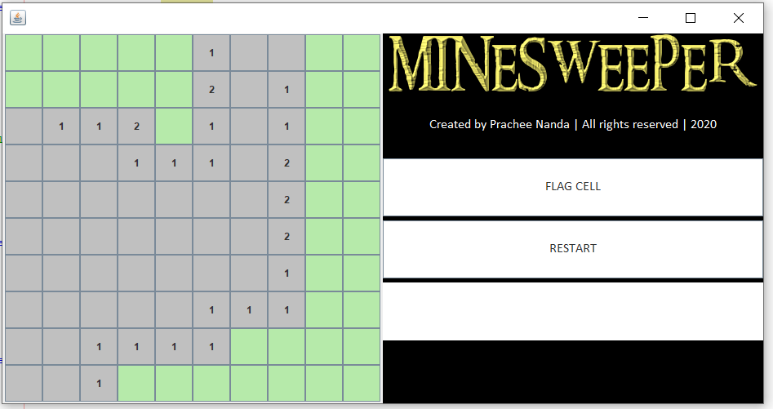Case #6:

Input: The button in the first column, 7th row

Output: Recursion function output

Remarks: This test was done to test the recursion function on an edge.

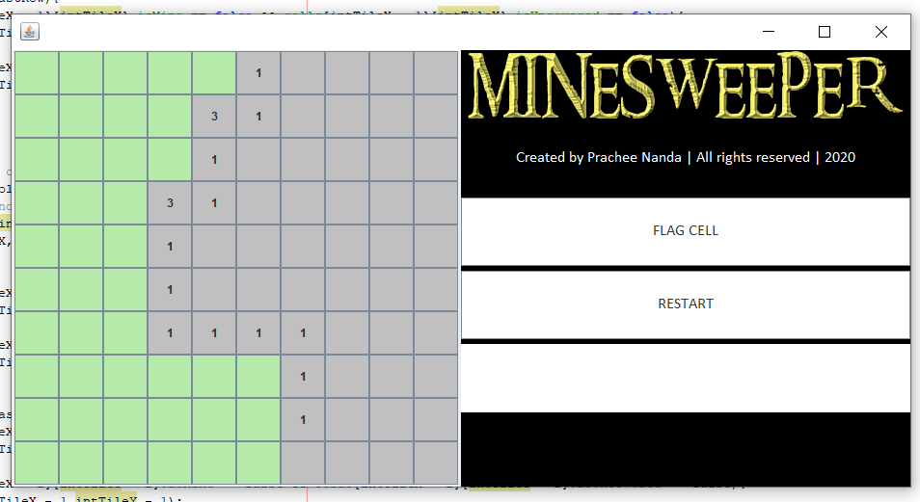

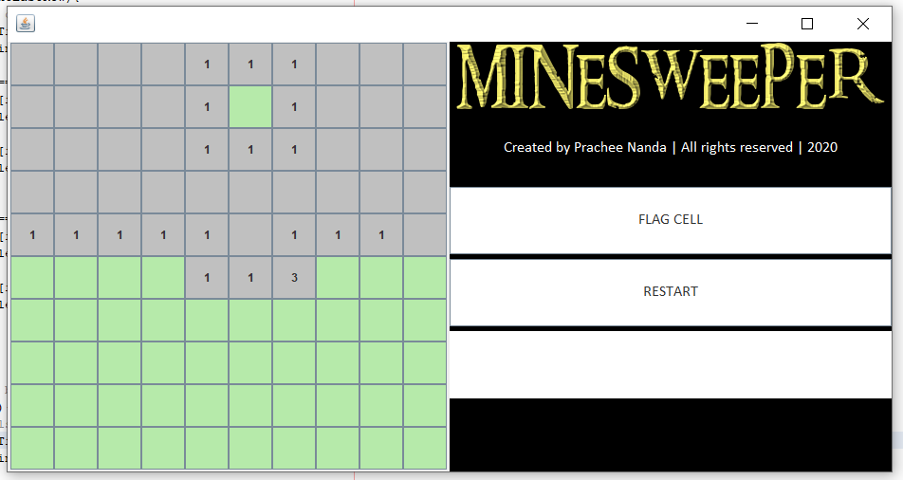Case #7

Input: The button in the last column, 7th row

Output: Recursion function output

Remarks: This test was done to test the recursion function on an edge.

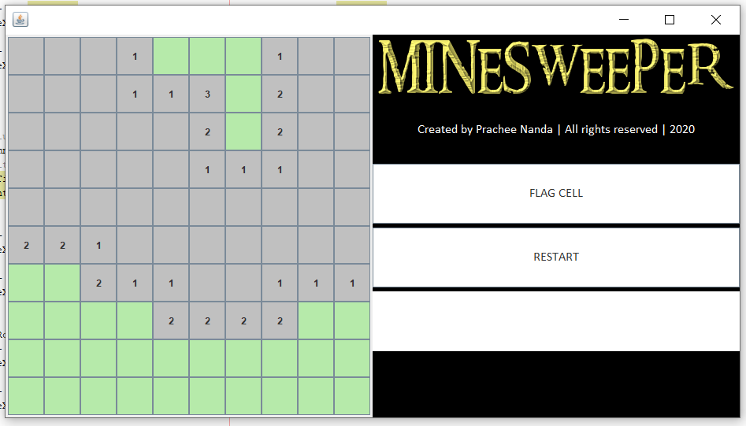Case #8

Input: The button in the fourth row, fourth column

Output: Recursion function output

Remarks: This test was done to test the recursion function on an edge.

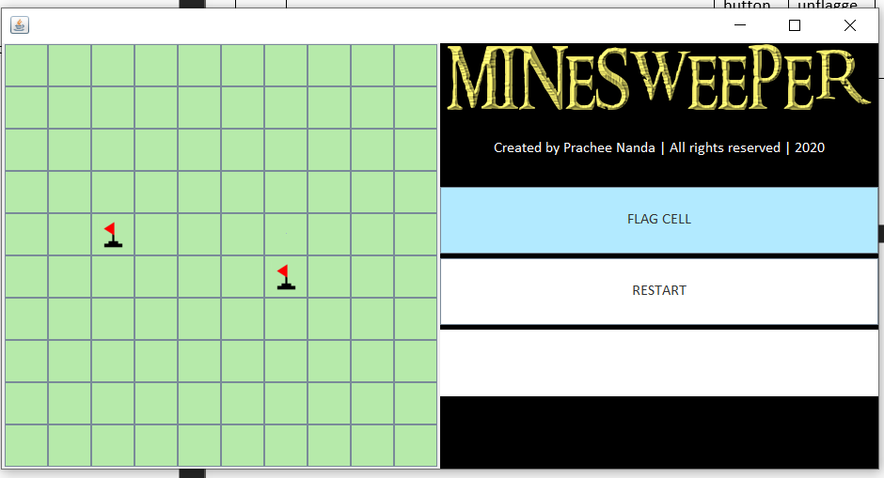Case #9

Input: Unflag a flagged cell

Output: Green tile

Remarks: This test was done to ensure a cell is not flagged forever

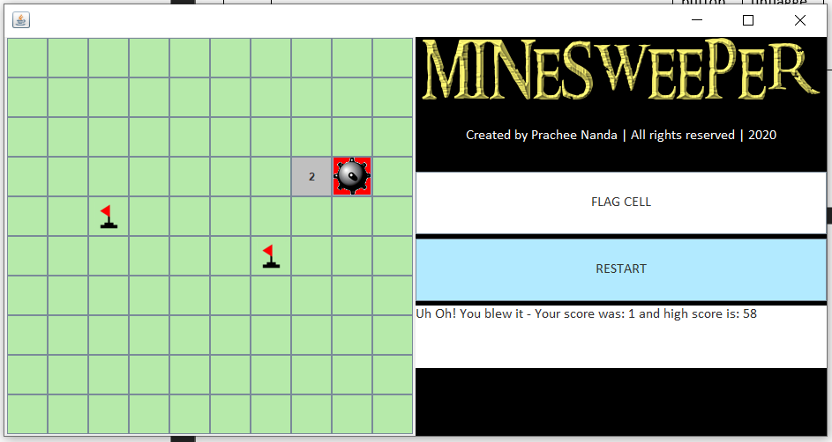Case #10

Input: Flag a cell that has a mine, then unflag it

Output: Mine resulted in game over

Remarks: This test is to ensure that a tile that has been previously flagged and then, unflagged, will still revert back to its original state.

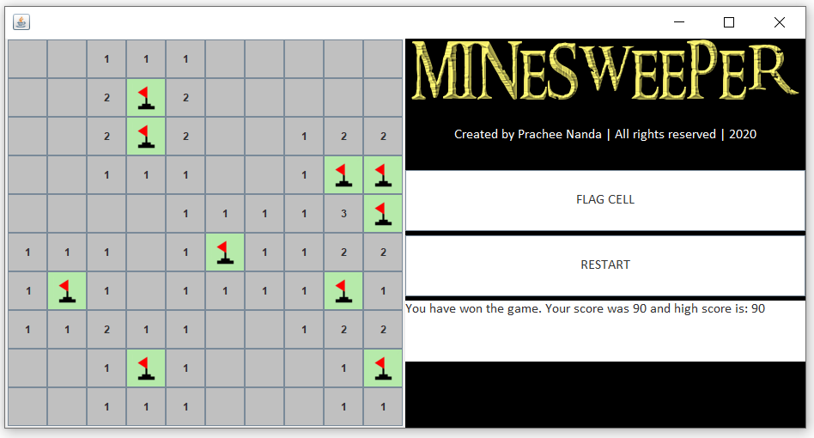

Case #11

Input: All green tiles with no mines

Output: Text field declares that game has been won

Remarks: This is to ensure that the game can be won



Case #12

Input: Flag a cell that has been uncovered

Output: No result

Remarks: This is to ensure that no cell can be flagged

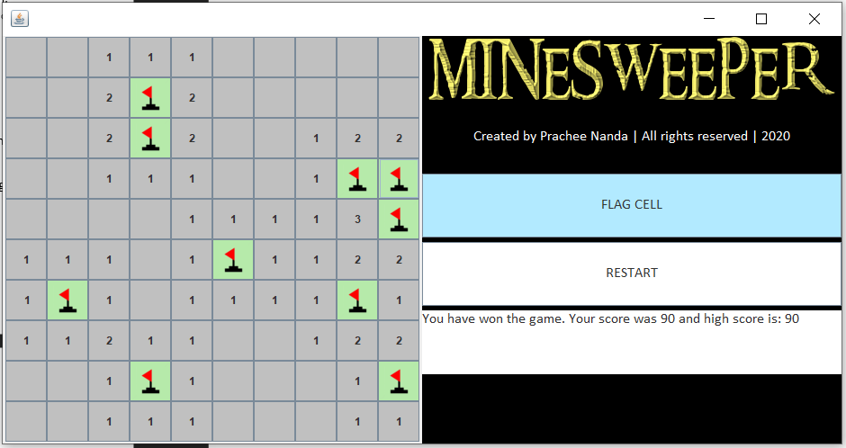Case #13

Input: Unflag a cell that has a flag after game has been won

Output: No result

Remarks: This is to ensure player can not unflag a cell, detonate mine and trigger game over screen when game has been won